A* ALGORITHM
Aim
To write a Python program to implement the A* search algorithm to find the shortest path from a start node to a goal node.
Objective
- To understand the A* search algorithm.
- To find the optimal path between the start node and the goal node.
- To use the cost function f(n) = g(n) + h(n) to select the best node.
- To display the shortest path and its total cost.
Algorithm
- Start.
- Read the graph, start node, and goal node from the user.
- Initialize the open list with the start node.
- Set the cost of the start node as g(n) = 0.
- Calculate the evaluation function using f(n) = g(n) + h(n).
- Select the node with the lowest f(n) value from the open list.
- If the selected node is the goal node, display the path and total cost.
- Otherwise, expand the selected node and find its neighboring nodes.
- Calculate the g(n), h(n), and f(n) values for each neighbor.
- Add the unvisited neighboring nodes to the open list.
- Repeat the process until the goal node is reached.
- If the goal node cannot be reached, display "No Path Found".
- Stop.

Flowchart
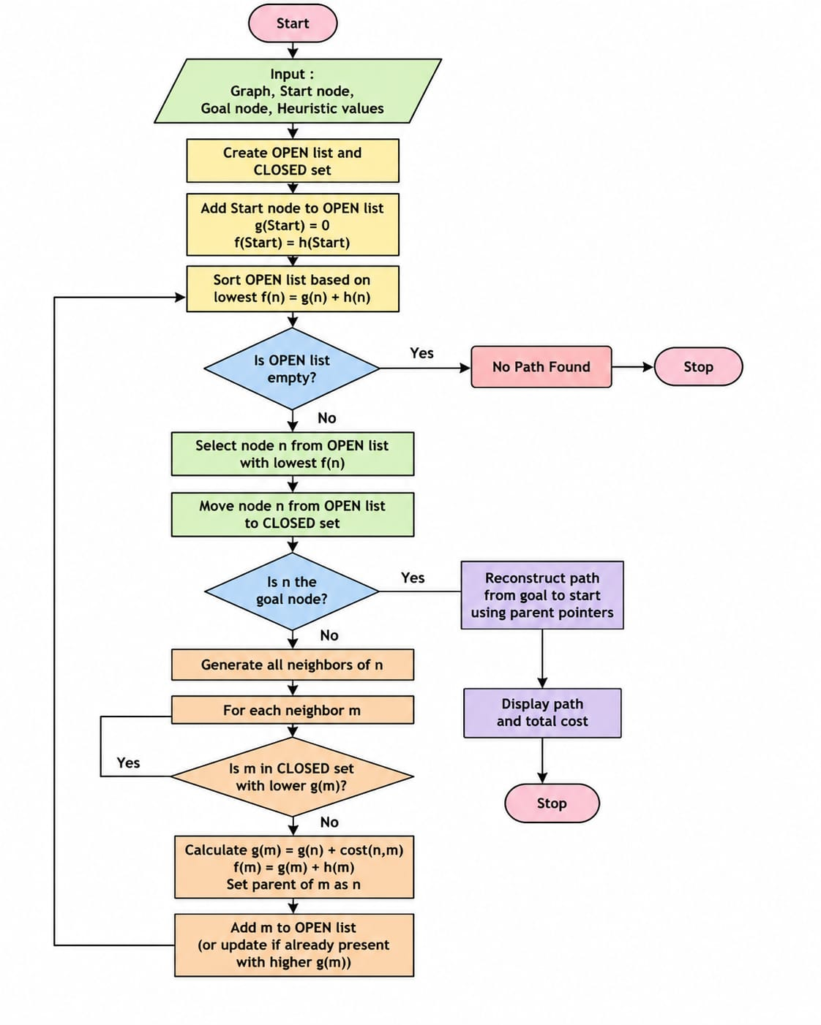
Python Code
import heapq

def astar(graph, heuristic, start, goal):
pq = [(heuristic[start], start)]
g_cost = {start: 0}
parent = {start: None}

while pq:
f, current = heapq.heappop(pq)

if current == goal:
path = []
while current is not None:
path.append(current)
current = parent[current]
path.reverse()
return path, g_cost[goal]

for neighbor, cost in graph[current]:
new_cost = g_cost[current] + cost

if neighbor not in g_cost or new_cost < g_cost[neighbor]:
g_cost[neighbor] = new_cost
parent[neighbor] = current
priority = new_cost + heuristic[neighbor]
heapq.heappush(pq, (priority, neighbor))

return None, None

graph = {}
n = int(input("Enter number of nodes: "))

for _ in range(n):
node = input("Node name: ")
graph[node] = []

e = int(input("Enter number of edges: "))

for _ in range(e):
u = input("Source: ")
v = input("Destination: ")
w = int(input("Cost: "))
graph[u].append((v, w))
graph[v].append((u, w))

heuristic = {}
print("\nEnter heuristic values:")
for node in graph:
heuristic[node] = int(input(f"{node}: "))

start = input("\nEnter start node: ")
goal = input("Enter goal node: ")

path, cost = astar(graph, heuristic, start, goal)

if path:
print("\nOptimal Path:", " -> ".join(path))
print("Total Cost:", cost)
else:
print("No Path Found")
Output
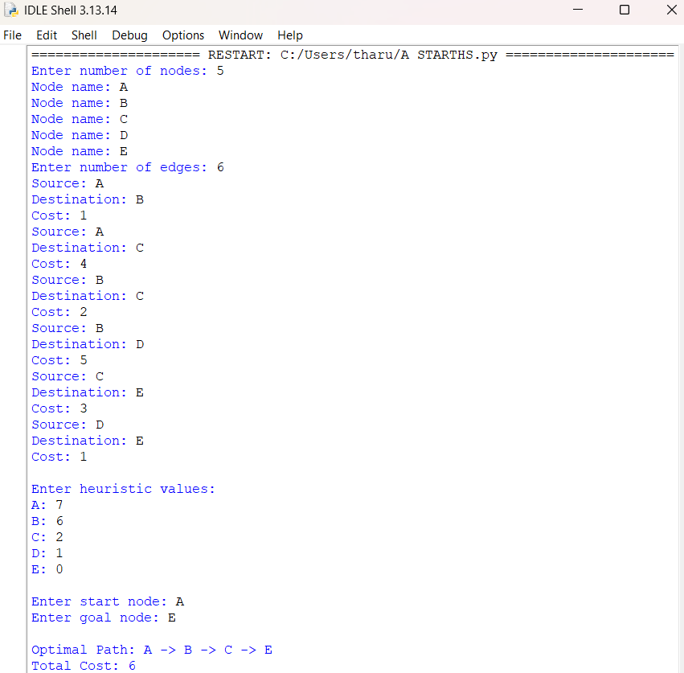
Result
Thus, the Python program to implement the A search algorithm* was executed successfully.
Conclusion
The A* algorithm successfully found the shortest path from the start node to the goal node by using the evaluation function f(n) = g(n) + h(n). The algorithm efficiently combines the actual path cost and heuristic cost to find an optimal solution.

